8. MARGINALIZATION OF CHRISTIANS

Economic Causes, Effect And Cure

Excellencies, distinguished guests, participants of the Maronite Congress, ladies and gentlemen.

I thank the organizers of this Congress, through Dr. Elias Ayoub, for giving me this opportunity to contribute to your reflections. My experience as World Vision National Director for Lebanon, Syria and Jordan from 1984 to 1999, and my present position with World Vision International as the Director – Resource Development, Middle East, has given me a certain competence to share with you my views on the Marginalization of Christians: Economic Causes, Effects and Cure. Specifically, I’m addressing the subject of the emigration of the Lebanese family.

First, allow me a few minutes to introduce to you the organization I represent, World Vision International. For this, I will use a PowerPoint presentation.

Last month I participated at a conference for the Middle East Council of Churches in Lebanon. I had the opportunity at that time to discuss the issue of emigration from Lebanon with various groups of people, religious and social leaders as well as individuals, who confirmed your fear and concerns regarding this topic.

I am indebted to the Pontifical Mission – Lebanon office, for making their report on the subject available to WVI and for sharing with you at this Congress.

Emigration from Lebanon

The first large wave of emigration from Lebanon began in the late 19th Century, following the civil war of 1860. Most emigrants went to Egypt, France, the United States, Australia and Latin America, where the largest concentration went to Brazil. The second wave of emigration began when civil war began in 1975. Some studies indicate that approximately 900,000 people have emigrated during the last 15 years of the war.

According to a study done by Information International published in Al Nahar newspaper dated Nov 26 and 27, 2001, some of the results will be mentioned later on. Information International based its studies on different statistics and a study performed by its staff.

Information International conducted a study published by Al Nahar newspaper in November 2001. Information International collected data about emigration for the period between 1991 and 2000. In this study Information International contacted the embassies of several countries. To verify their findings, they studied a sample of 1,087 Lebanese families representing 5,890 persons.

The study by Information International sought to answer two questions:
- The number of people that left Lebanon during the past 10 years.
- The areas and social sectors affected by emigration.

The study discovered that the main reasons for emigration from Lebanon are economic, social and political, and that the number of emigrants had increased during the period that was studied. Here are some specific findings.

Findings
By the end of 2000, Lebanon’s registered population was 4,672,746. Residents were estimated at 3,451,000, which meant that there were 1,221,746 persons living outside Lebanon. This number included those who have a Lebanese identity card regardless of the year they emigrated. For this reason, the number of emigrants between 1991 and 2000 is less than what is commonly known (i.e., 1 million emigrants during the past 10 years).

Causes of Emigration
The survey identified the following causes of emigration:

- 66.3% Unavailability of work possibility in Lebanon
- 10.8% Political and security problems
- 8.5% Willingness to live abroad
- 4.7% Unavailability of education for children
- 4.0 % Economic situation in Lebanon
- 3.3% Not precise
- 1.4 % Absence of law
- 1.0% All points mentioned above

Embassies’ Figures
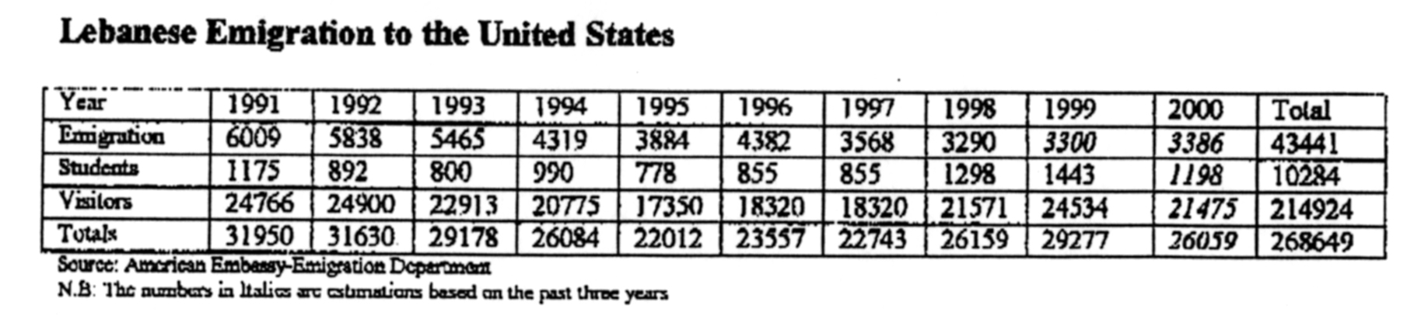
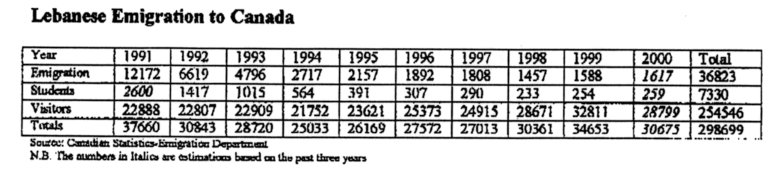
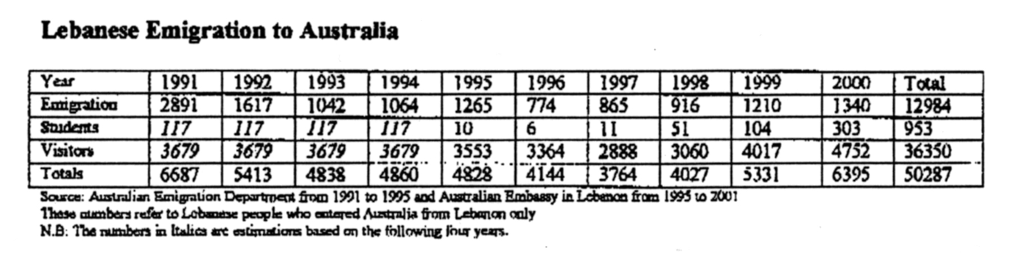

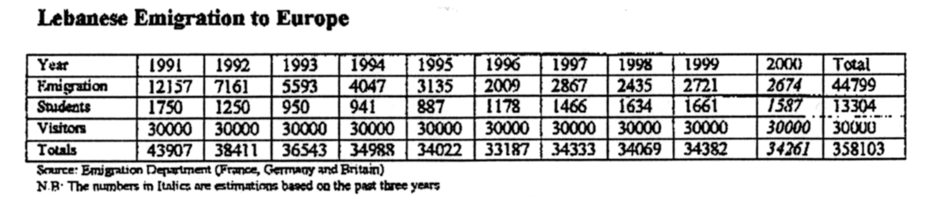

The most alarming figure is the youth figure represented by students, and by families who emigrate with their children. In addition, a high percentage of the people in the visitors’ category remains illegally in these countries and do not return to Lebanon.

Effects
Some of the following points summarize the current situation:
- During the last 10 years, the total number of emigrants (official and non-official) is 200,000 to 300,000 persons.
- The highest rates of emigration occurred in 1991, 1992, 1993. A gradual decline began in 1994, and 1995 to 2000 show approximately the same emigration rate.
- In the last 10 years the average number of emigrants according to embassies is 13,800 per year.
- If current emigration rates continue (20,000 to 30,000 per year) with the same sociological aspects, it will lead to a higher percentage of elderly people in Lebanon and decreases the percentage of population growth.
- The most educated persons represent the highest percentage of emigrants.
- Those who live in Mount Lebanon represent the highest percentage of people willing to emigrate followed by the inhabitants of the Bekaa and then by Beirut.
- Approximately 232,000 persons look forward to leaving the country and work abroad.

Other Sources

Here are more facts and figures on emigration from other sources:
- The Economic and Social Committee for West Asia (ESCWA), a UN agency, estimated annual emigration for the last year is 31,331.
- Studies by the Middle East Council of Churches state that there are approximately 85,000 Lebanese living in nine countries in Western Europe.
- The magazine Commerce du Levant, in September 2001, notes that emigration to Canada began before World War I.
- The Lebanese Consulate in Montreal confirms that the trend to Canada has increased since 1988. Today there are 250,000 Lebanese people living in Canada

Addressing the Issue
We Lebanese are first responsible towards the people of our dear country Lebanon. We should consider them as an extension of our own families. We must be willing to take risks by investing in our country and people, and helping rebuild the economy.

In Lebanon today there are institutions committed to help those in need. They have proven themselves over the years to be dedicated and committed; they are legally established and worthy partners. Permit me to mention few of these organizations: Pontifical Mission Lebanon, Caritas Lebanon, World Vision Lebanon, Moral Rearmament, MECC and many others.

May I challenge you to adopt a new concept to help those in Lebanon who do not have any connection to the Diaspora? The tendency has been to help the immediate and extended family, as well as family-related persons. Should we not also help a person or family that we do not know and who has no one to help them? Please keep on doing what you are doing, but we can all do more.

Helping the people feel safe and secure will lead to a sense of belonging to the country; but this is missing due to the unrest in the region that has been and continues to boil. Investing in the private sector based on individual private initiatives can lead to economic prosperity.

Here are some practical suggestions:
- Micro enterprise opportunities
- Create job opportunities
- Support reasonable tuition fees and good education for children and youth
- Subsidized medical care
- Loans for couples to be married for housing

May I remind you that the subject of emigration is not a new subject—it has been repeating itself over many years? But this time is different. This time we are losing our youth, and as we lose them we lose the potential to re-build and shape a better future for our country.

In closing let me quote Pope John Paul II: “Lebanon is more than a country, it is a massage.” Let us all continue to work together to keep the flame of this message burning.

Thank you.

Jean (John) G Bouchebl

Director
Resource Development – Middle East
Tel: (262) 301 7711; Fax: (626) 301 7779 Email: jean_bouchebl@wvi.org

